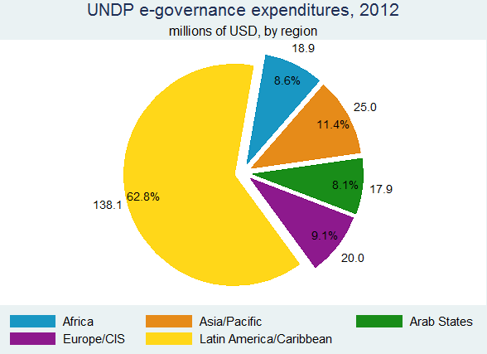  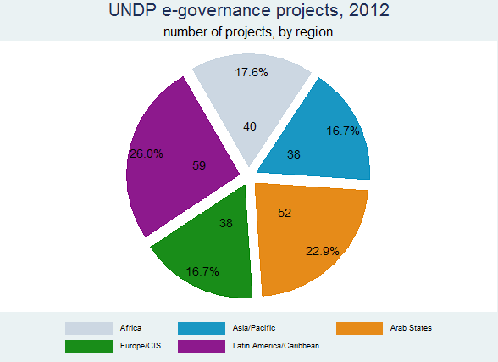  Outcome | 2.3 | Access to information policies support accountability and transparency
Evidence of results (corresponding to sections 1 and 2 in the narrative)

Evidence of POSITIVE results – 2008 to 2012Positive evidence of progress based on outcome indicators (to the degree possible, characterize evidence by groupings or types rather than individual countries, e.g. by region, typology, output dimension, etc.)
In 2012, the Access to Information service line accounted for 2.4% of projects and 2.7% of the total outcomes of the democratic governance practice. In terms of expenditures, the service line represented 3.9% of total practice expenditures (248 million USD). The service line has its largest expenditures in MICs followed by T&NCC countries. Since 2008, expenditures in the service line have increased by close to 60%, while the number of projects have increased 15%.

From a regional perspective, service line expenditures in 2012 were concentrated in Latin America and the Caribbean, followed by EECIS and the Arab States. Argentina is responsible for this shift as the regional distribution in 2008 of both expenditures was more balanced across regions.

In terms of outcomes, the service area contributed to 14 outcomes in RBLAC, 12 in RBEC and 11 in RBAS. However, the number of outcomes has decreased 10% since 2008 -although the trend is changing as numbers for 2009 and 2010 were even lower according to ROAR reports.

In the 2008-2012 period the sub-practice directly supported over 60 programmes and projects on the ground with both funding and policy advise. At least half of the initiatives were supported as they focused on harnessing innovations to address traditional development gaps. Unlike other areas of work, ICTs and e-governance are a moving target as continuous innovation is a trait which takes place at almost the speed of light. The potential for delivering new solutions to old or traditional development gaps is thus enormous in the sub-practice as innovative solutions constantly pop up. The sub-practice also provide indirect (desk) support to another 50 countries in the 5 year period comprised by this report.
Positive evidence of progress based on outcome progress (to the degree possible, characterize evidence by groupings or types rather than individual countries, e.g. by region, typology, output dimension, etc.)
- Review country outcome status data from 2008 to 2012, analyzing and referencing % of: achieved, positive change, no change, and not on track
While 10.2% of the outcomes were achieved, 85.5% are ongoing and well on track. Only 2.3% can be attributed to projects which are either off track or without established outcomes.

1.1.3. Successful contributions are characterized by (why has it worked?)
In Madagascar, 44,000 youth two rural communities submitted their views via text message on human rights, citizenship and employment to make their voices heard in policy-making processes. In Uzbekistan, one-stop shop centers provided 40 basic services, including birth registration and payment of utility bills that reached over 200,000 people in the first year of operations. In Costa Rica, the Social Security Agency is benefiting from UNDP’s expertise on ICTs and e-governance and asked for support for modernizing the institution via innovation and new technologies. In Bangladesh, the Access to Information (A2I) programme prioritized and mainstreamed ICTs into the national development policy and supported emerging ICT initiatives.

These initiatives have worked due to the following:
- Strong support from CO management and country partners
- Clear understanding of ICTs and e-governance as enablers for development -and not as goals on themselves.
- Local capacity available to manage, support and monitor programmes implementation
- Clear link between e-governance initiatives and national development agendas and priorities
- Adoption of innovative procedures and technologies to address local bottlenecks
- Strong M&E and impact assessment methodologies, implanted from the very beginning of the programmes
Supporting evaluative evidence of positive results (thematic, ADR, donor surveys and reports, etc.)
Evidence of LESS THAN SUCCESSFUL results – 2008 to 2012
    - Negative evidence of progress based on outcome indicators (as in 1.1.1)
- Review outcome indicator data as in 1.1.1
See above
    - Negative evidence of progress based on outcome progress (as in 1.1.2)
- Review outcome status data as in 1.1.2
See above
    - Unsuccessful contributions characterized by (why have we been less successful?)
Usually, UNDP ICT for development programmes are not successful due to the following reasons:
- Initiatives focus too much on the technology and not of the development output and potential impact
- Programmes are not align with ongoing CO activities and in some cases even compete with them for resources
- Projects are usually managed by technology experts who cannot liaise or connect with programme staff in Cos and in counterpart offices
- There is little to no buy in from senior managers both inside UNDP and in government.
    - Supporting evaluative evidence of negative results (thematic, ADR, donor surveys and reports, etc.)
  - Additional evidence
    - Other evidence, rationale, or clarifications
As a cross-cutting service line, sub-practice activities usually get reported under other corporate outcomes. Based on this knowledge the sub-practice has undertaken its own mapping exercises on an annual basis. While the official ROAR reports only a small number of countries with ongoing initiatives, the latest mapping report for 2012 shows that close to 100 countries are implementing ICT for development and/or e-governance initiatives.
A typical example here is Bangladesh - a well-known and very successful Access to Information programme which is somehow reported under the Access to Justice outcome
According to preliminary mapping results for 2012, UNDP was supporting 228 e-governance projects in 92 countries. The estimated overall expenditures of these projects amounted to US$221million. E-governance activities have increased from 117 projects in 53 countries in 2007.
The LA region ranked first in terms of expenditures, accounting for $138 million or 63% of the total $221million. Asia-Pacific had a total expenditure of $25 million, 11% of the total expenditures on e-governance. Compared to 2007, the regional distribution of expenditures shows a similar picture.
In terms of number of projects, they are relatively evenly distributed. The largest number in 2012 was in the Latin American, which comprised 26% of the total number of e-governance projects. The geographical distribution of e-governance projects has changed significantly since 2007. Five years ago, the regions hosting most e-governance projects were Europe and the CIS as well as Asia Pacific covering 27% and 22% of all projects.
With regards to the distribution of e-governance projects across UNDP development categories, about two thirds of the expenditures ($146 million) have been made in upper middle income countries (UMIC). The distribution among all other categories is quite well balanced ranging from $25 million to $17 million (11% - 6%). Exceptions are net contributing countries (NCC) accounting for $3 million or 1% of the total expenditures.
About 29% and 22% of the projects were implemented in UMICs and LMICs respectively/ The third largest number of projects is in countries in special development situations (SDS) amounting for 19% of all projects. Least developed countries (LDCs) and lower income countries (LICs) account for 16% and 10% respectively.

- UNDP contributions (corresponding to section 3 in the narrative)
  - Characterization and rationale
    - Explain how UNDP engages and contributes to this outcome
- Include how UNDP contributions and approaches have evolved or changed from 2008 to today
UNDP has been supporting the area of access to information since the early 2000s. However, capitalizing on the rapid growth and diffusion of new Information and Communications Technologies (ICTs) in the last 10 years, UNDP's contribution has been focused on harnessing them to support this area in innovative fashion.
New ICTs offer to people the potential of using new and affordable communications channels and get their voices heard in relevant governance process. At the same time, ICTs can enhance access to public information by reducing production and distribution costs thus allowing stakeholders to meaningfully participate in decision-making processes.
On the supply side, that of public institutions, UNDP has ensured that governments are more responsive to citizens demands for public information and services and assisted them in strategically deploying new ICT solutions that focus not on access to technology but rather on the delivery of services to the people. To bring both supply and demand together in the context of rapid changing ICTs, UNDP developed a e-governance framework depicted in the chart below.
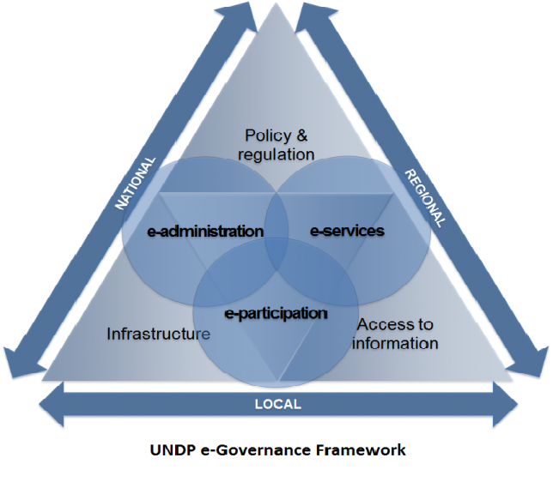

The framework focused on how public investment decisions are made and how will they impact on the well-being of citizens. It has three core components: e-administration, e-service delivery and e-participation; and three cross-cutting components, including traditional access to information approaches. There is a clear intersection between the e-participation and access to information components of the framework.

In the last 5 years, UNDP's e-governance programming has shifted within the context of the framework. While in 2008 most of the e-governance activities were focused on access and connectivity by then end of 2012 most programme countries were focusing on e-service delivery and e-participation (including access to information).

In that same period of time, the rapid diffusion of new Information and Communication Technologies (ICTs) has made them available to most if not all developing countries. Social networks and in particular mobiles technologies -which is now available to over 4 billion people in the developing world, are changing the way in which development assistance is provided in general and on how governments and citizens interact in the public sphere. This is opening new doors for innovative governance approaches and bringing the emerging middle classes in developing countries into the governance discussions. We are perhaps witnessing a shift from traditional e-governance to ICT for governance where both supply and demand are on a more leveled playing field.

    - Characterize UNDP contributions by output dimension (e.g., changes through time by country, variances by cluster, etc.)
- If contributions to this outcome are typically characterized or structured in an additional way (by cluster, etc.) discuss here as well
    - Discuss any UNDP contributions to this outcome addressing often “hidden” areas (e.g., human rights, anti-corruption, development effectiveness areas, etc.)
As a cross-cutting components ICT for Development and e-governance programmes and initiatives are not only reported under more traditional democratic governance services lines but are also integral part of the outputs under such corporate outcomes. The table below presents the information in this regard for 2011:

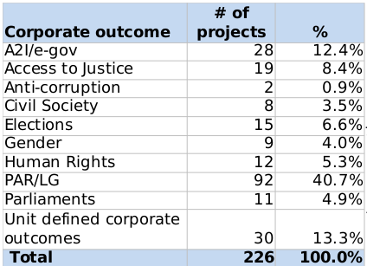
Most of the e-governance activities are reported under the public administration and local governance corporate outcome (over 40%), followed by undefined corporate outcomes with 13%, access to justice with 8% and electoral support with close to 7%. Of particular interest here is those reported under unit defined corporate outcomes as it shows that Cos have no place to report cross-cutting ICT for Development and e-governance activities.
A quick glance at these projects indicate that this is indeed the case.

  - Challenges, lessons, and proposed improvements
    - Challenges UNDP faces in contributing to this outcome
One of the key challenges to this area of work emerges from the rapid advancement of new ICTs in developing countries vis-a-vis the lack of uptake by core UNDP programmes and projects. While many in-house still perceive ICTs and e-governance as a pure technical issue (or as yer another tool), local innovators in developing countries are taking the lead and deploying basic on the ground solutions that could be easily used by UNDP to support MAF related efforts for example ans scale up ongoing initiatives. The risk here for UNDP is to suddenly be seen as falling behind in the development agenda.
An additional challenge has emerged from the innovation wave that seems to be now reaching UNDP. While this in principle is certainly welcome, the risk here is to ignore the work UNDP has done since 1993 in the area of ICT for Development which has essentially been driven by innovation. It is clear that innovation, like ICTs, are a means to and end and UNDP should build on what has already done in over 140 countries.
Finally, it is essential that UNDP takes a cross-practice approach when it comes to the sub-practice to allow for horizontal interventions on ICTs and e-governance and thus maximize band for the buck and makes less demands on CO capacity.
    - Lessons for UNDP relating to this outcome
- Consider lessons relating to: scaling up, inclusiveness, partners, multiple wins or cross-focus area, institutional capacities, knowledge sharing, South-South and TrC
- Include lessons learned through the 2008 to 2012 time period
By keeping up to speed on the latest developments in the are of ICT for development and e-governance, the sub-practice has been able to attract demand from UNDP CO which has encompassed close to 110 countries. Both internal and external reputation of the quality and expertise of the sub-practice team has contributed to enhance the demand for support and services. This has also translated to invitation by external partners to attend and speak at high-level global events which in some cases has led to new and innovative partnerships.
UNDP’s work in this area is clearly acknowledged by the international private sector as companies such as IBM and Microsoft has provided grants to support government institutions and building local e-skills respectively, while others such as Motorola provided grants to UNDP for mobile innovation for development in poor countries. Since 2010, the sub-practice has also been engaged with both the Broadband Commission spearheaded by ITU and UNESCO, and the Open Government Partnership launched by the Obama administration and nowadays co-chaired by the UK and Indonesia. In short, this area of work attracts the attention of the international ICT private sector and existing public-private partnerships.
The sub-practice has chosen to produce a few publications and instead focus on the quality of them and on using networks to disseminate knowledge and information. For example, it produced a flagship report on Mobile Technologies and Innovation , available in several languages, that has been downloaded by users in almost 100 countries and is now a standard reference among practitioners.
The report also reinforces yet another of the traits of the sub-practice: to promote South South cooperation. This is particularly so in emerging e-governance areas such as open data, open government, social innovation, social networks and mobile technologies. Social innovation in particular is key here as it is already taking place in many developing countries, many of which remain unaware of each other. As a global network, UNDP can make a big difference here by creating regional or global networks of innovators and thus bring additional knowledge and support to Cos.

    - Proposed improvements for UNDP to address relating to this outcome
See above.
    - Additional relevant information relating to this outcome

